Role-plays.
The demand and supply forms the basis of any business activity. To help understand this mechanism, the students are introduced to some simulated managerial situation. Faculty members assume the role of customers or regulatory authorities and the student groups are asked to introduce their ideas to potential consumers as well as funding agencies.

Role Play for RD and Calibration of Transducers for Temperature Measurement on

1. Introduction to the Role Play Scenario
The role play involves two students participating in a technical demonstration or discussion about the calibration of Resistance Temperature Detectors (RTDs) and transducers used for temperature measurement. The goal is to simulate a real-world RD (Research and Development) scenario where calibration and precision are critical.
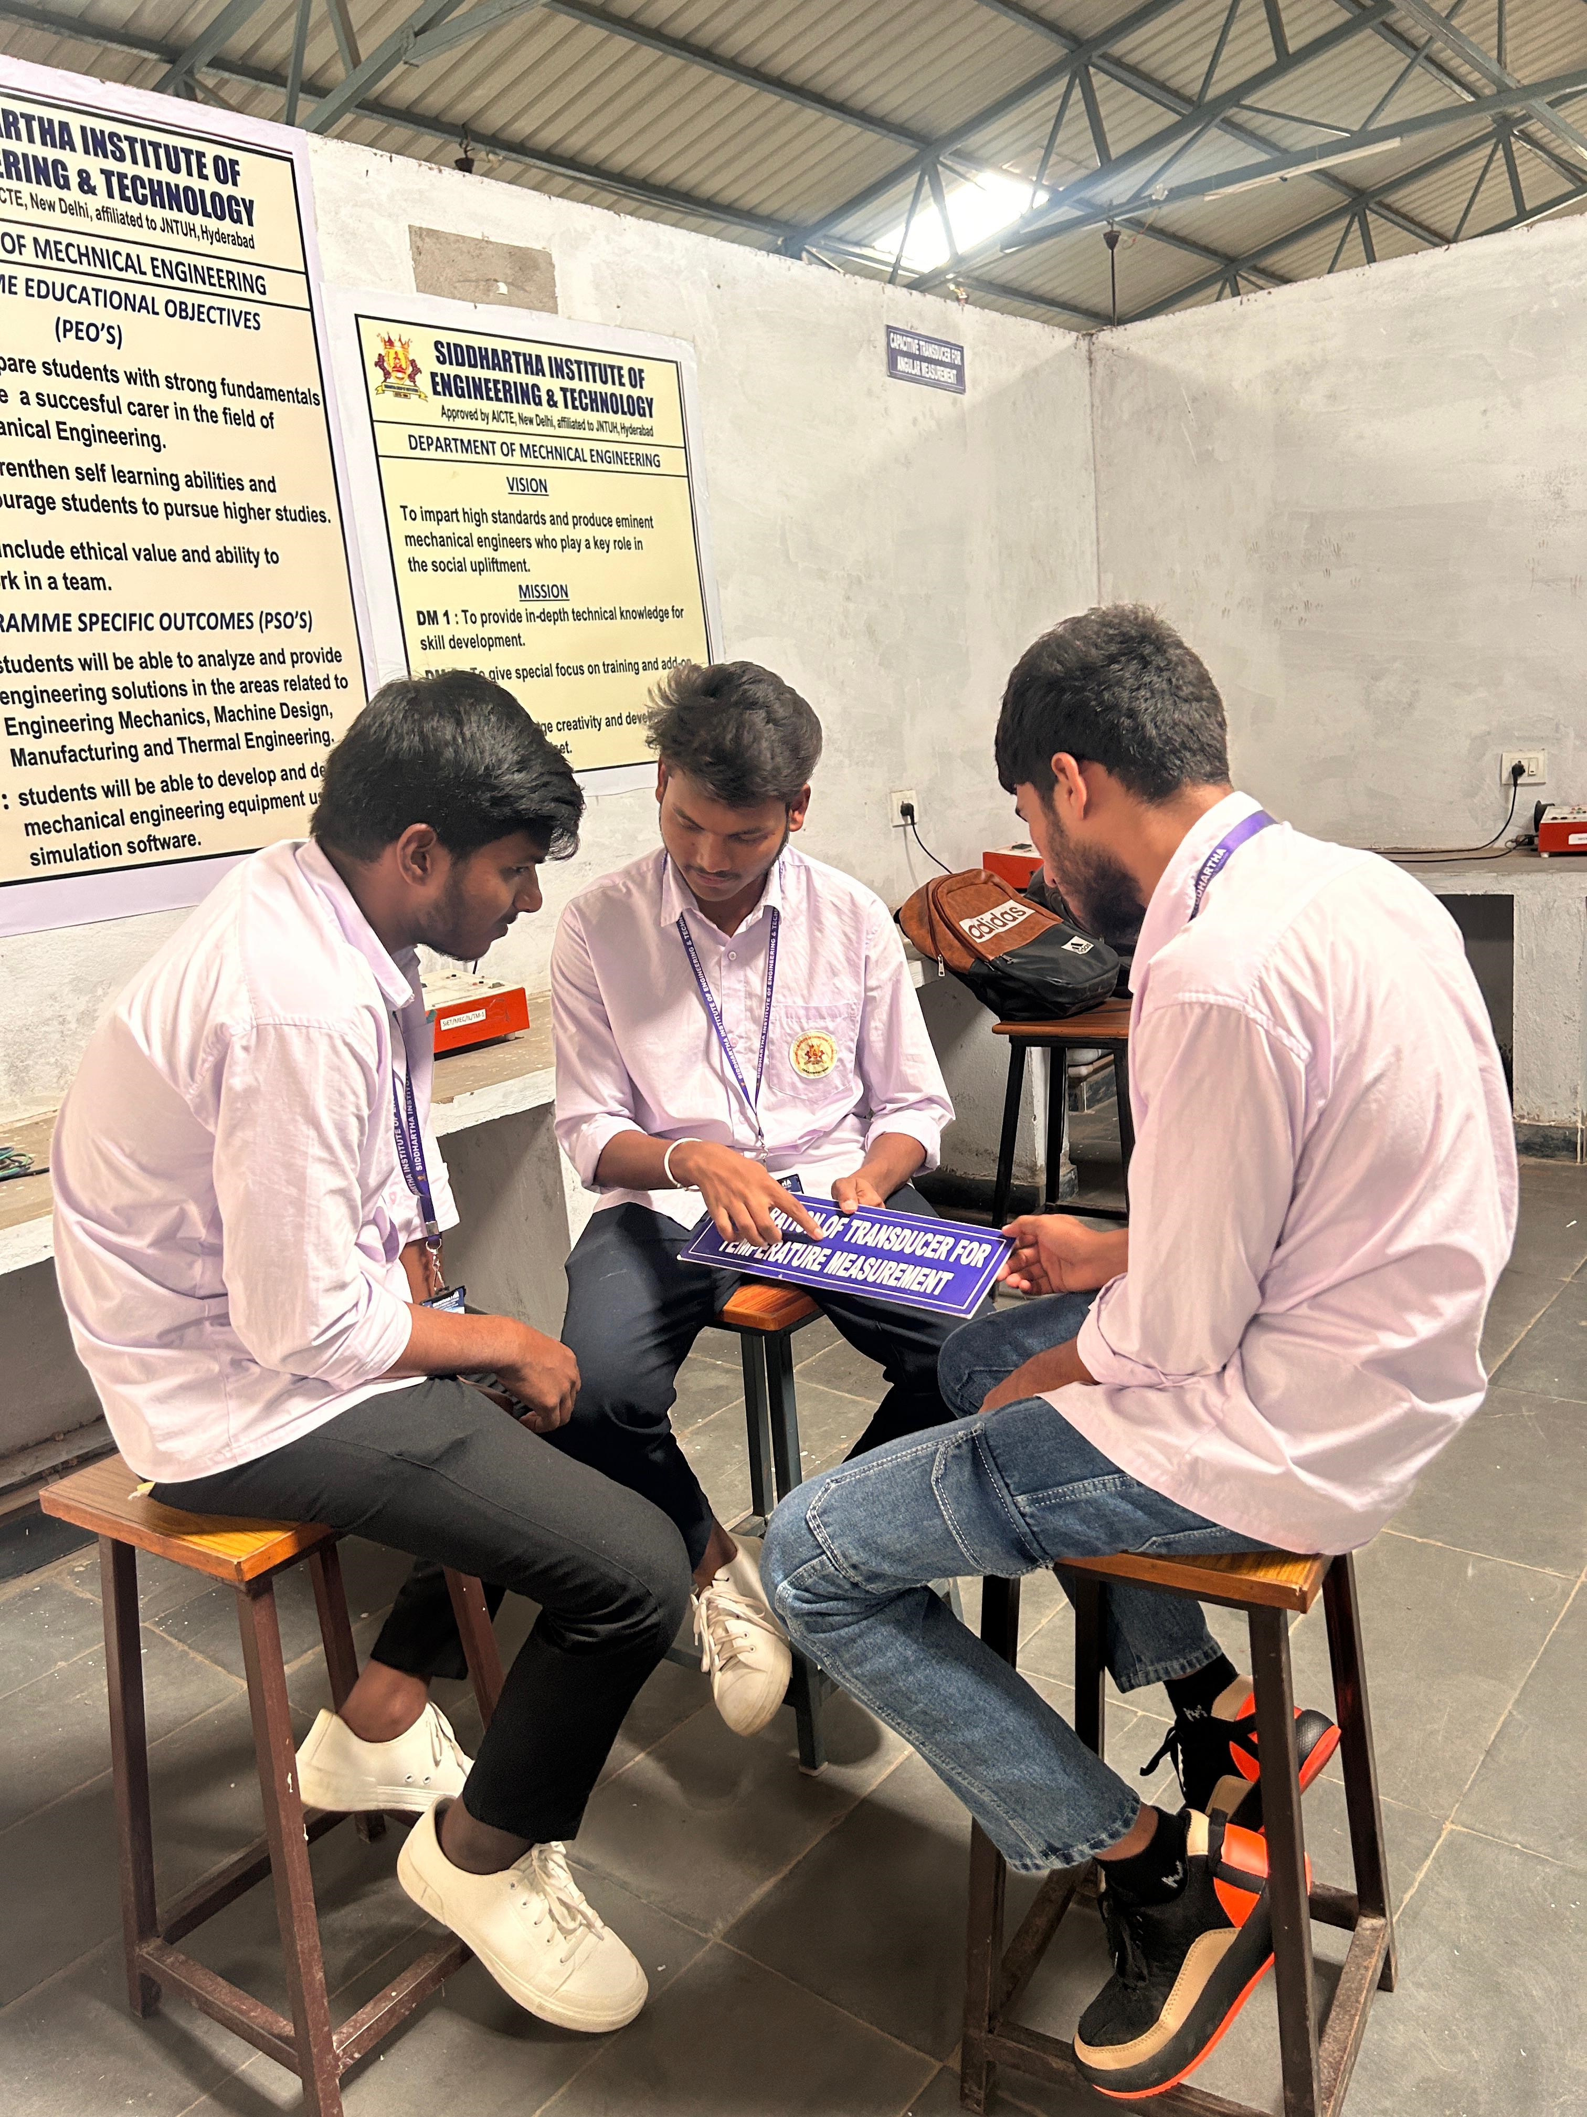
Students Group disunion about Calibration transducer temp measurement

Students Group d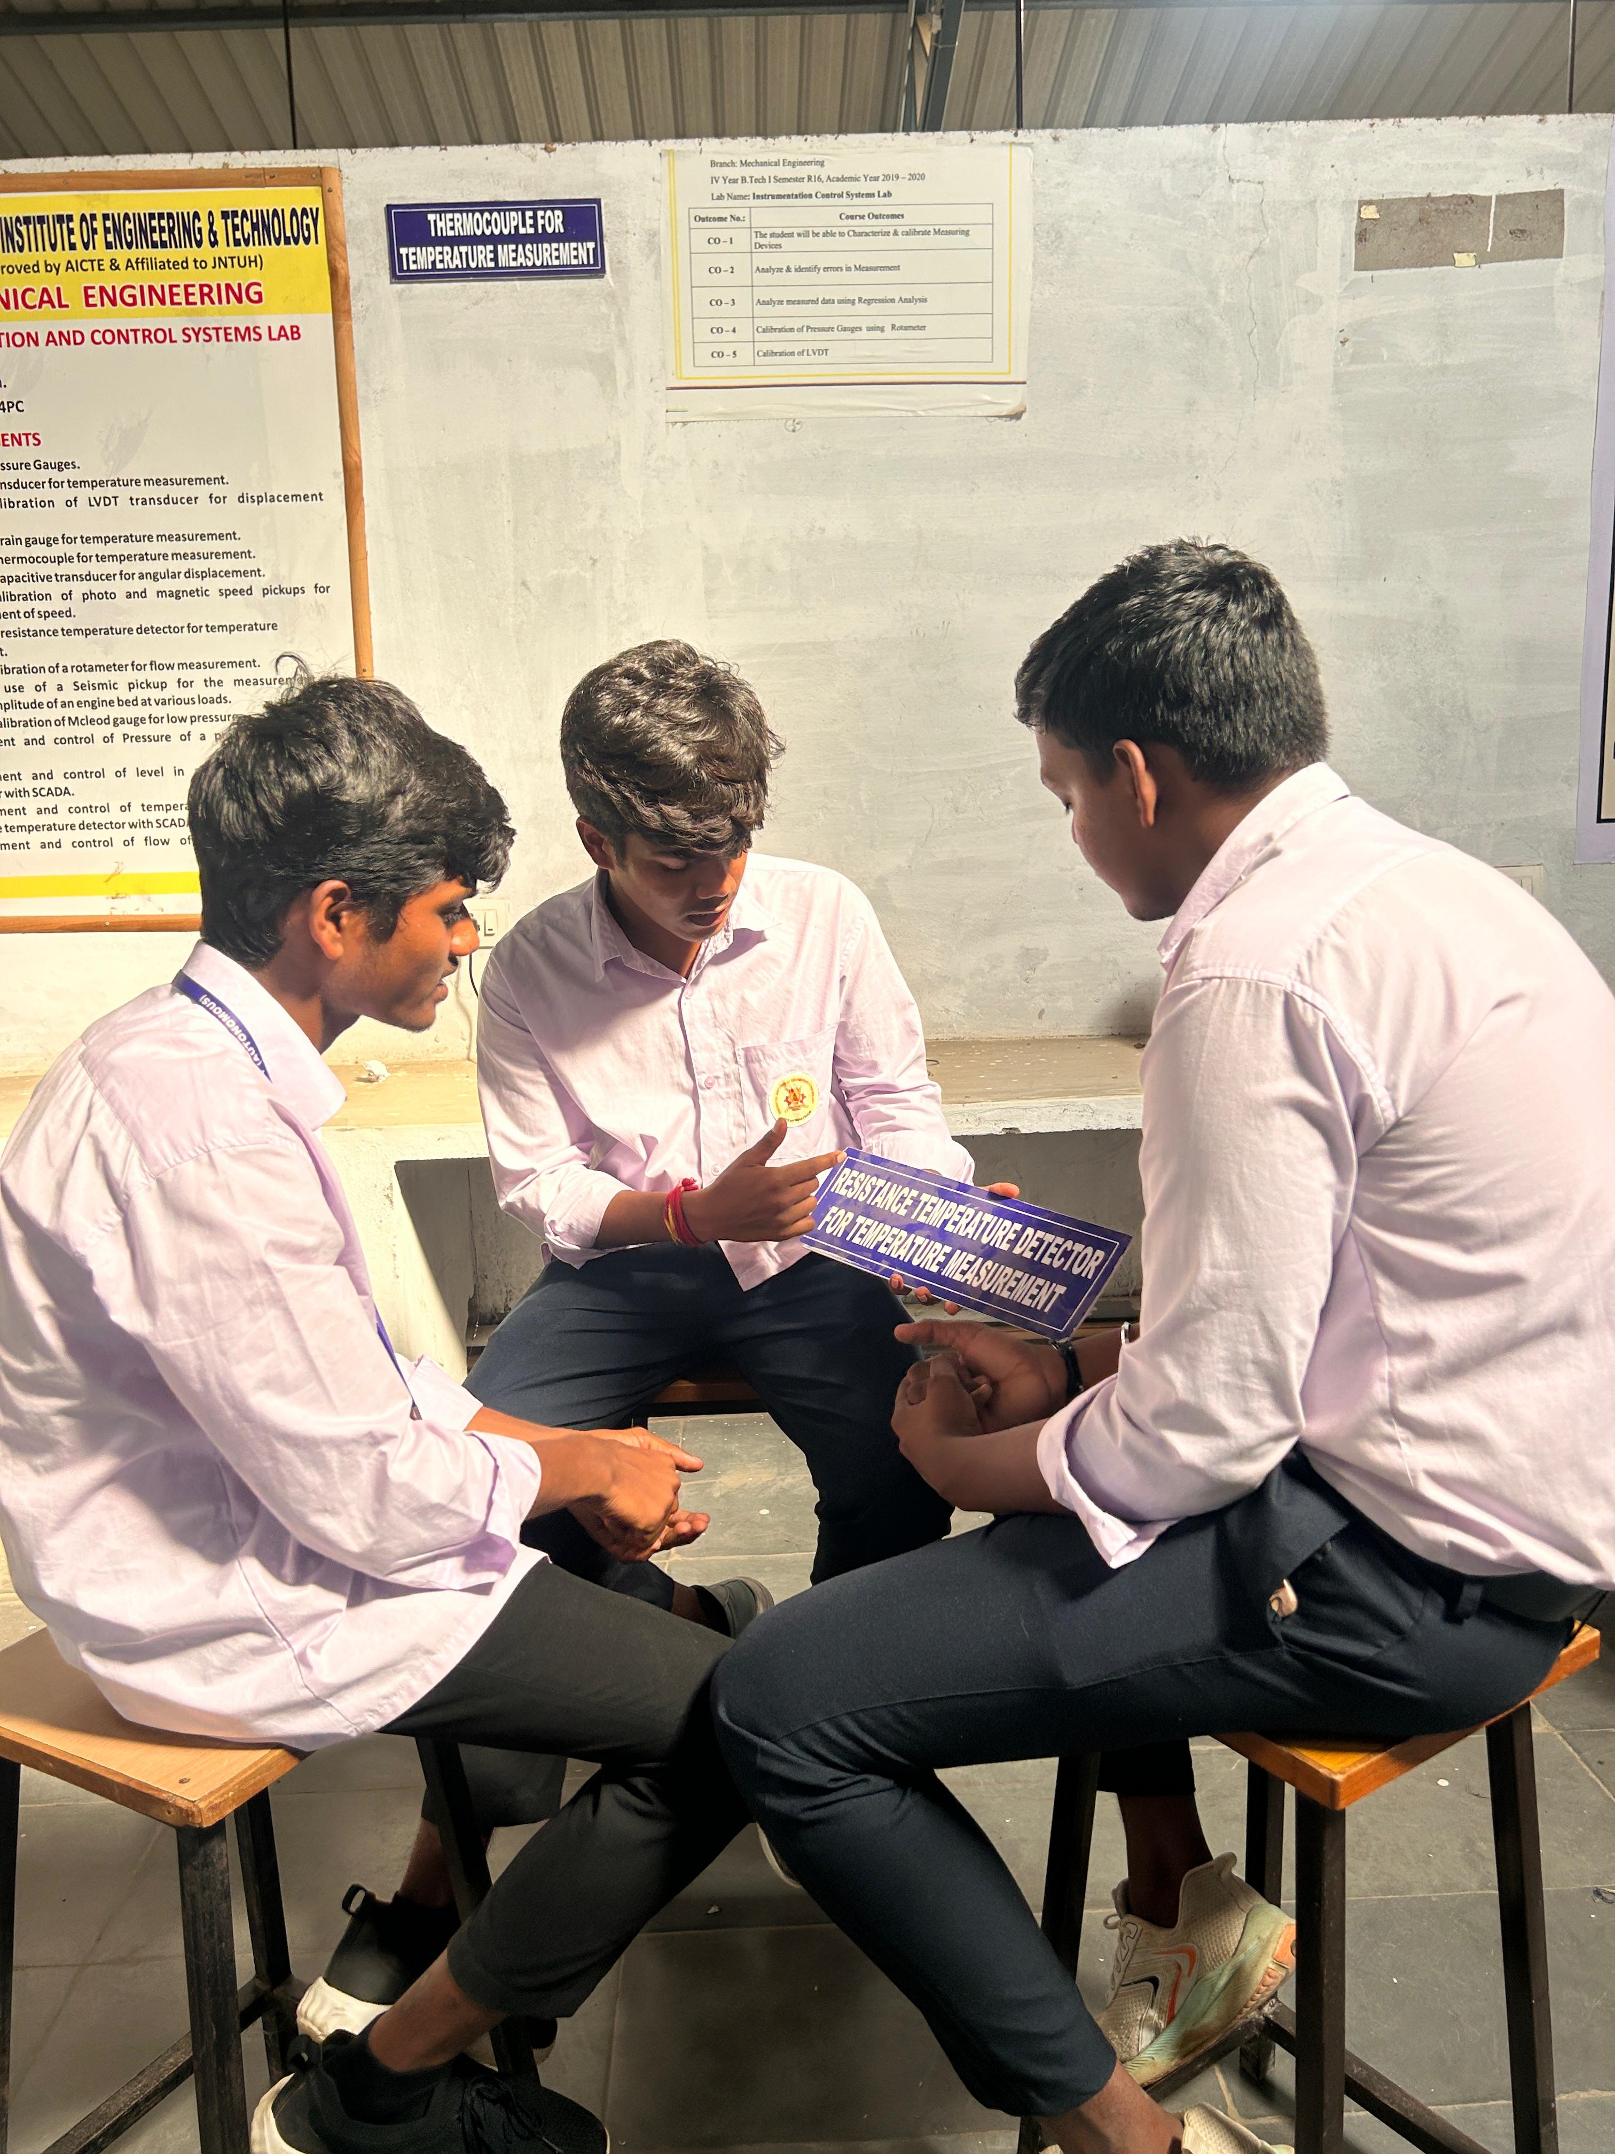Disunion about RTD
The role-play effectively demonstrates the importance of calibration in temperature measurement, focusing on the usage of RTDs and the transducer calibration process. Innovations in the calibration techniques, such as automation and integration of AI, continue to drive improvements in RD for instrumentation and control systems.

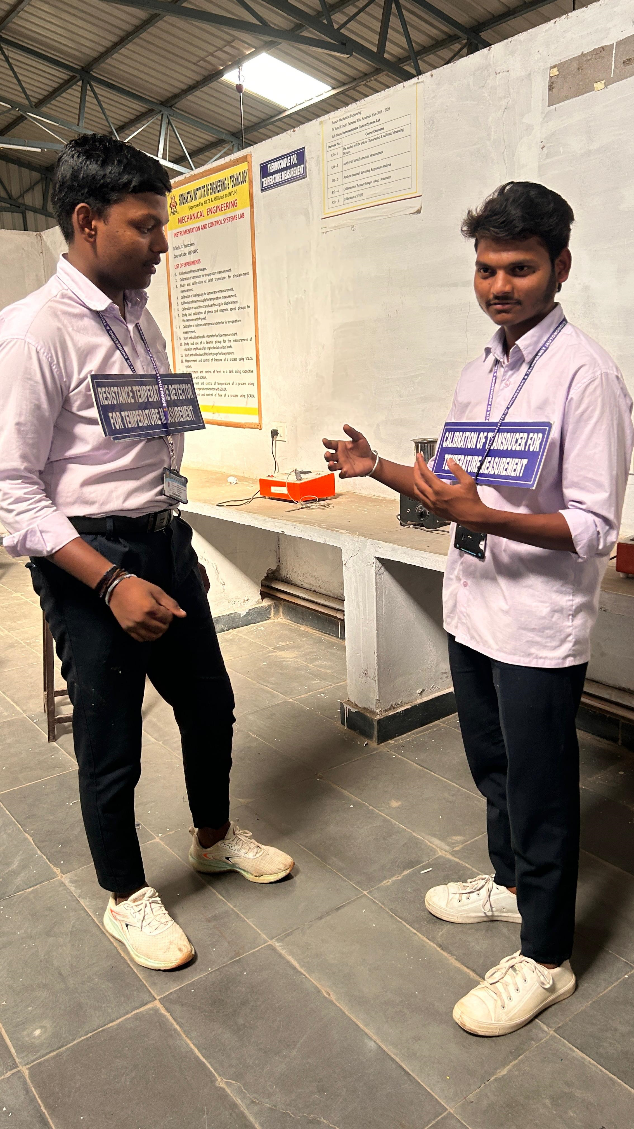
Students are participated to role play.

Role Play Report: Digital vs. Manual Thermometers

1. Introduction
This role play demonstrates the comparison between digital and manual thermometers in a classroom setting. It focuses on how each thermometer works, their pros and cons, and the innovations in teaching these concepts.

2. Scene Overview
- Digital Thermometer: Uses electronic sensors to quickly provide a numerical temperature reading on a digital display.
- Manual Thermometer: Measures temperature by the expansion of mercury or alcohol, requiring more time for the reading and manual interpretation.

3. Role Play Highlights
- Digital Thermometers: Students discuss the quick, accurate readings and their use in medical and industrial settings.
- Manual Thermometers: Students learn about the slower readings and the risks of mercury, as well as the traditional applications.

4. Innovations in Teaching
Role play encourages active participation, helping students:
- Compare both thermometer types in real-world scenarios.
- Understand how technology has improved temperature measurement.
- Discuss the pros and cons of each, promoting critical thinking.

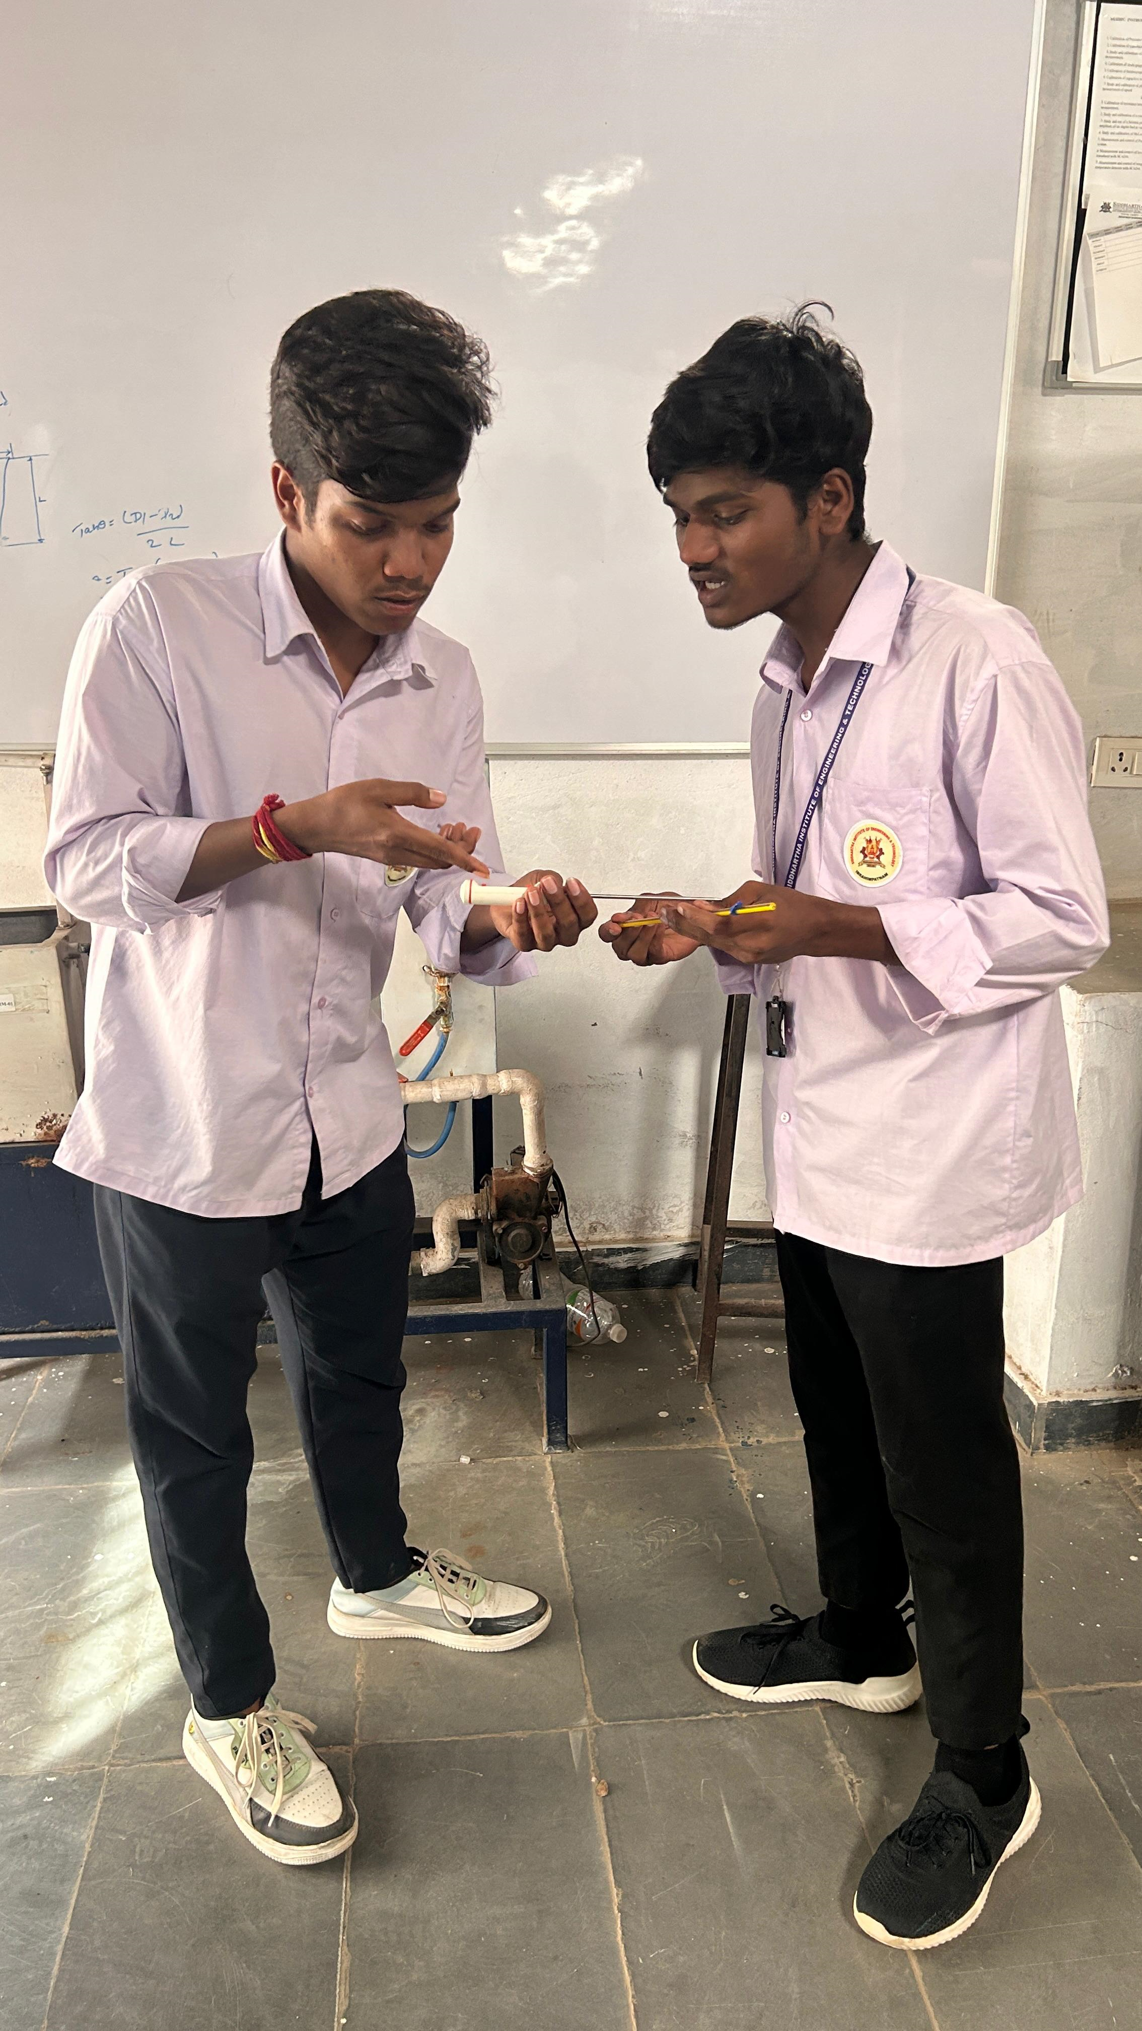

5. Conclusion
The role play enhances understanding of temperature measurement tools and encourages innovative teaching methods that engage students in practical, hands-on learning. By comparing digital and manual thermometers, students grasp both historical and modern advancements in measurement technology.

Role-plays.
The demand and supply forms the basis of any business activity. To help understand this mechanism, the students are introduced to some simulated managerial situation. Faculty members assume the role of customers or regulatory authorities and the student groups are asked to introduce their ideas to potential consumers as well as funding agencies.

Role Play: Solar Energy vs. Wind Energy – Batch Discussion

Characters:
- Presenter 1 (Advocate for Solar Energy): Focuses on the benefits and importance of solar energy.
- Presenter 2 (Advocate for Wind Energy): Highlights the advantages of wind energy.
- Presenter 3 (Energy Expert): Moderates the discussion, offering insights and helping the group come to a conclusion.
Group of experts or students (batch) is hosting a discussion about renewable energy options, specifically comparing solar energy with wind energy. They have gathered in a science seminar room equipped with props—like solar panels and wind turbine models—for a more interactive session.
Presenter1 (Solar Energy Advocate):
“Welcome everyone to this exciting session on renewable energy. Let’s begin by discussing solar energy—arguably the most accessible and abundant renewable energy source. Solar panels are scalable, meaning they can be installed on rooftops or in vast solar farms. The sun provides a virtually limitless resource, and once solar systems are in place, they require minimal maintenance. In regions with abundant sunlight, solar energy is one of the most effective ways to generate power. Furthermore, solar is environmentally friendly—no emissions or pollution during its operation.”
Presenter 2 (Wind Energy Advocate):
“Thanks, Presenter 1! While solar is a great option, wind energy also deserves attention. Wind turbines can generate large amounts of power, especially in areas where winds are strong and consistent. Coastal regions or open plains, for instance, are prime locations for wind farms. Wind energy works day and night as long as there’s wind. It’s a clean and renewable resource that doesn't emit any harmful pollutants during its operation. Wind power is also becoming more efficient, and it creates many jobs in the process—from installation to maintenance.”
Presenter 3 (Energy Expert):
“Both solar and wind energy are excellent choices, but they come with some challenges. For solar energy, the most significant limitation is its reliance on sunlight. Solar panels only generate power during the day, and their efficiency decreases on cloudy days. So, regions that don’t receive a lot of sunlight might not be able to harness solar power effectively. What do you think, Presenter 1?”
Presenter 1 (Solar Energy Advocate):
“That’s true, Presenter 3. Solar energy is intermittent—it depends on the weather and daylight hours. But technological advancements in energy storage—like batteries—are helping overcome this limitation. In fact, we can store excess energy generated during the day for use at night. Also, solar panels are becoming more affordable, making them a great option for individuals, businesses, and even entire cities.”
Presenter 2 (Wind Energy Advocate):
“Great point, Presenter 1! But let’s not forget that wind energy also faces intermittency issues. Wind turbines only generate power when the wind is blowing, and if the wind stops, they stop working. Plus, wind farms need a lot of space to be effective, especially in urban areas. However, offshore wind farms are addressing this challenge by utilizing strong winds over the ocean. We’re seeing exciting growth in offshore wind energy, and it’s a promising solution for large-scale power generation.”
Presenter 3 (Energy Expert):
“Absolutely, offshore wind farms are a great example of how technology can overcome space and efficiency limitations. But let’s also consider the aesthetic and noise concerns associated with wind turbines. Some people find them visually unappealing, and the noise from the blades can be disturbing, especially for those living nearby. Solar panels, on the other hand, are much less intrusive. You can install them on rooftops or in areas that don’t disrupt communities.”
Presenter 1 (Solar Energy Advocate):
“That’s right, Presenter 3. Solar panels are silent, and they can be placed on top of buildings or homes without impacting the surrounding environment. In terms of initial cost, though, solar panels can be expensive to install, but as technology advances and more people adopt them, costs are dropping steadily. So, with the right incentives and policies, solar can become even more accessible.”
Presenter 2 (Wind Energy Advocate):
“I agree with you. Solar has a lot of potential, but don’t forget that wind energy can produce far more power in the right conditions. For example, large wind farms can generate massive amounts of electricity—enough to power thousands of homes. Wind energy also provides long-term job opportunities, which helps communities grow economically. As turbine technology improves, they are becoming more efficient and quieter, addressing some of the initial concerns.”

Presenter 3 (Energy Expert):
“Exactly. Both solar and wind energy have their advantages, but the future likely lies in a combination of both. We need to recognize the complementary nature of these resources. Solar can provide power during the day, and wind can help provide energy at night or during overcast weather. By combining both, along with energy storage solutions, we can ensure a consistent and reliable energy supply. Together, solar and wind energy will be key to reducing our reliance on fossil fuels and tackling climate change.”
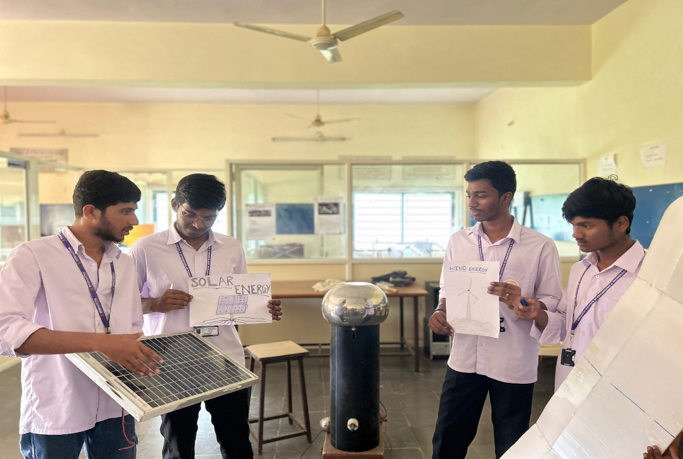

Conclusion (All Presenters):
“In conclusion, solar and wind energy both play crucial roles in building a sustainable energy future. While each has its own strengths and challenges, together they offer complementary solutions to meet our growing energy needs. The key is to innovate and invest in both, alongside energy storage and grid improvements, to create a cleaner, greener world for the future.”

